Design Updates
URL:
http://us15.campaign-archive1.com/?u=12a794b2402eb103cba5c25f4&amp;id=dcae832268
- Post my Flight Button - Button needs to be moved further left
Currently:
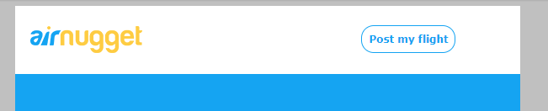
Updated:
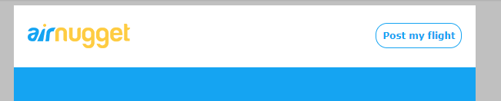
- Update background image (background image has plane with lines not just blue background)
Current:
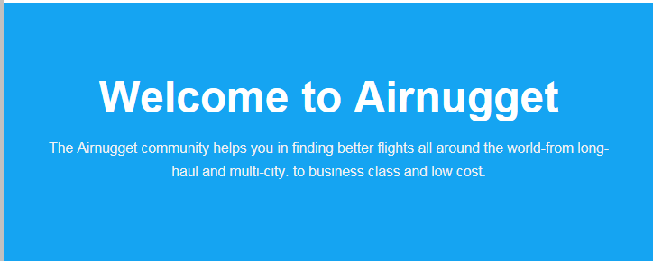
Update
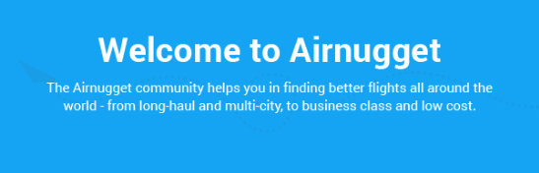
- All 3 icons are too small and blury – size of icons not same as provided designs – please increase size also please make sure the icons are not blurry and have good resolution
Currently
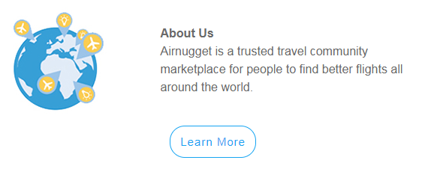

Update – Icon Should be sized same as below
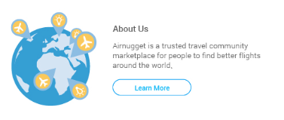
- Buttons are not aligned with text – all 3 buttons are not aligned with text
Current:
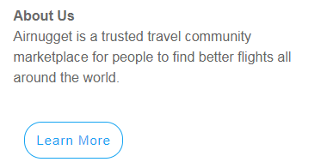

Update – the buttons need to be aligned and close to the text above
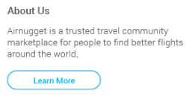
- Button Link URL – Please update as below
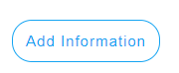
https://airnugget.com/user_profile
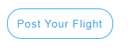
https://airnugget.com/


https://plus.google.com/116469662694192725459/about

- Update Airbnb wording
Currently:
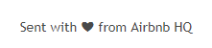
Update:
Sent with “heart” from Airnugget HQ

- Logo Link – Add link to Logo

https://airnugget.com/

